DS.140 Integration Design Specification



EMR Item Outbound Integration

Author: Nidhi

Creation Date: Feb 15, 2024

Last Updated: Feb 15, 2024

Version: 1.0

**Approvals:**

|  |  |
| --- | --- |
| <Approver 1> | <Rakesh Khanna / Naushad / Amit> |
| <Approver 2> | <Business Owner> |

# Document Control

## Change Record

| Date | Author | Version | Change Reference |
| --- | --- | --- | --- |
| 15-Feb-2024 | Nidhi | 1.0 | No Previous Document, Draft version |
|  |  |  |  |
|  |  |  |  |

2

## Reviewers

| Name | Position |
| --- | --- |
| FHL Business | Business User |
| FHL IT Group | Fortis IT Team |
|  |  |
|  |  |

Contents

1 Document Control ii

1.1 Change Record ii

1.2 Reviewers ii

2 Introduction 5

2.1.1 Scope for this Document 5

2.1.2 Intended Audience 5

3 Overview 6

3.1 Business Objectives 6

3.2 Major Features 6

3.3 Glossary 6

4 High-Level EMR OUTBOUND Workflow 7

5 Oracle Fusion 8

5.1 Data Model 8

5.2 Report 9

6 Oracle File Processing 11

6.1 SFTP Server 11

6.2 Bash Script Processing 11

7 Oracle PAAS database 15

8 EMR System 18

8.1 EMR Services 18

9 Data FIELD Mapping 19

9.1 Field to Field Mapping 19

9.2 Frequency 19

9.3 File Format 19

10 Exception handling 20

10.1 Scenarios 20

11 Assumptions / Considerations 21

12 Open and Closed Issues 22

12.1 Open Issues 22

12.2 Closed Issues 22

# Introduction

### Scope for this Document

This analysis specification document is prepared to layout the Item Outbound design of outbound integration to EMR system.

### Intended Audience

This document is intended for the following groups to provide the action items and consideration that are required to complete the implementation of the various Finance, Supply Chain, HR outbound to EMR system from Oracle Fusion.

#### Fortis Business Users

This document will be helpful for Fortis Business users to understand the technical design and process change with the new structure implemented in Oracle. The business user will validate this document after the verification of the requirement.

#### PwC Technical Team

The PwC technical team will use this document as a source technical design document to develop the technical solution to implement / deploy outbound integration to EMR system from Oracle Fusion.

#### Fortis IT Team

The Fortis IT Team must facilitate the PwC technical team for requisite details and other elements required from Business. The Fortis IT team is also responsible to arrange and provide required technical information wherever is required.

# Overview

Fortis Healthcare Limited (FHL) is a chain of hospitals, headquartered in India. Fortis started its health care operations from Mohali where first Fortis hospital was started. Later, the hospital chain purchased the healthcare branch of the Escorts group and increased its strength in various parts of the country. The Fortis health care also operates its hospital in Vasant Kunj, Faridabad, Gurgaon. The FMRI hospital at Gurgaon is the headquarter of Fortis healthcare with all the major facilities at the hospital.

This specification document is prepared to layout the common design of outbound integration to EMR systems. The outbound integration would from the Oracle cloud to EMR. The data flow would be through Oracle PaaS compute. PaaS system to be used for encryption and transformation.

## Business Objectives

The following are the business objectives.

1. To have a secure, reliable and scalable design flow from Oracle SaaS to EMR.
2. To have a solution providing the monitoring capabilities.

## Major Features

The proposed solution will have the following major features

1. SFTP Delivery
2. Synchronous REST Call with binary attachments.

## Glossary

REST

Representational State Transfer.

SFTP

Secure File Transfer Protocol

# High-Level EMR OUTBOUND Workflow

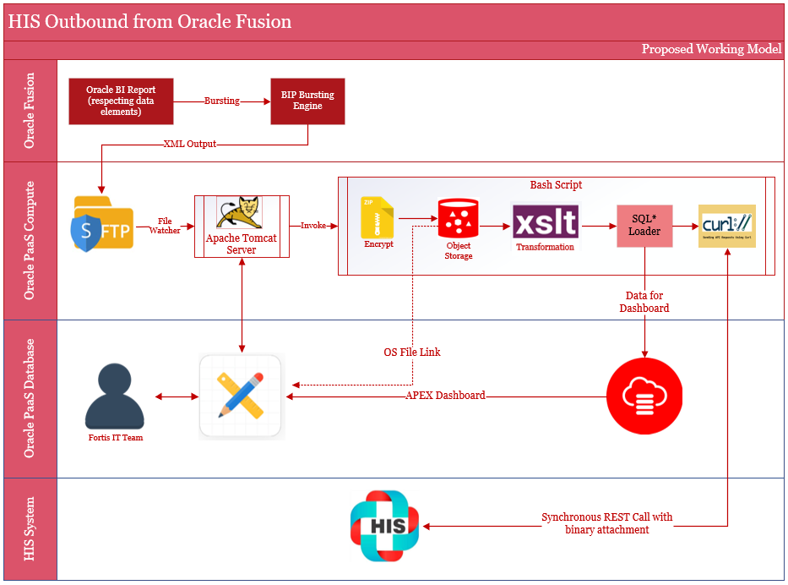

# Oracle Fusion

This section describes the Oracle Fusion component in detail.

Oracle BI Report will be developed and designed in BI Catalogue Shared Folder -> Custom path. The report will be based on data elements as per requirement from EMR.

Reporting bursting capability would be utilized to generate XML Outbound file. The report will be secured using SaaS application BI and Job Roles.

The frequency of report execution would be as per data required from EMR.

## Data Model

The custom data model would be designed as per data requirement from EMR. The data model provides the capability to write SQL query as per defined criteria. The parameter would be defined as per business requirement. Data model encapsulates the business logic for bursting report XML data.

#### Data Set Item Outbound

Data sets provides the feature to write standard SQL queries, view structure, data and code. Data tab is for visualization of the sample output, export of sample data and for saving sample data.

|  |  |  |  |
| --- | --- | --- | --- |
| SI No | Interface Name | Data Model Path | Data Model Name |
| 1 | EMR Item Outbound Report | /Custom/Interfaces/Integration Reports/Inventory/ | EMR Item Outbound DM |

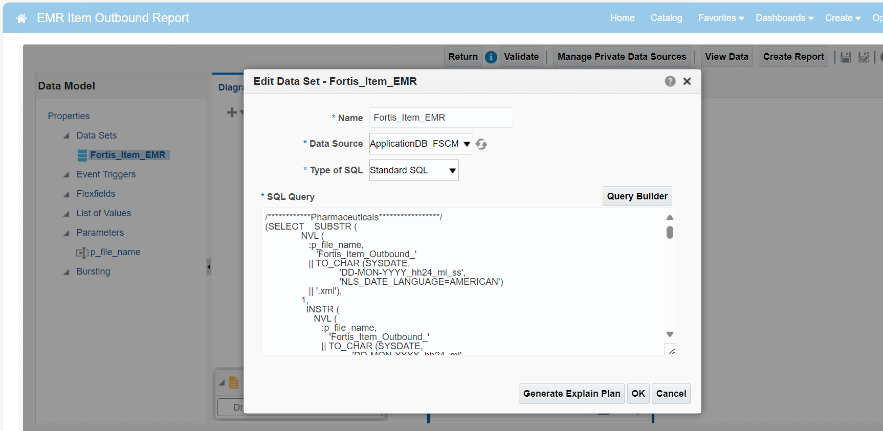

#### Bursting

This section enables you to write the report bursting logic. In this section you can define the deliver by, split by criteria and you’ll get the capability to write the bursting SQL for delivery channel.

#### Parameters

This section enables you to define the report parameters. In this section you can define the parameter name, data type, default values, parameter types, row placement etc. This section also enables you to make parameters as mandatory.

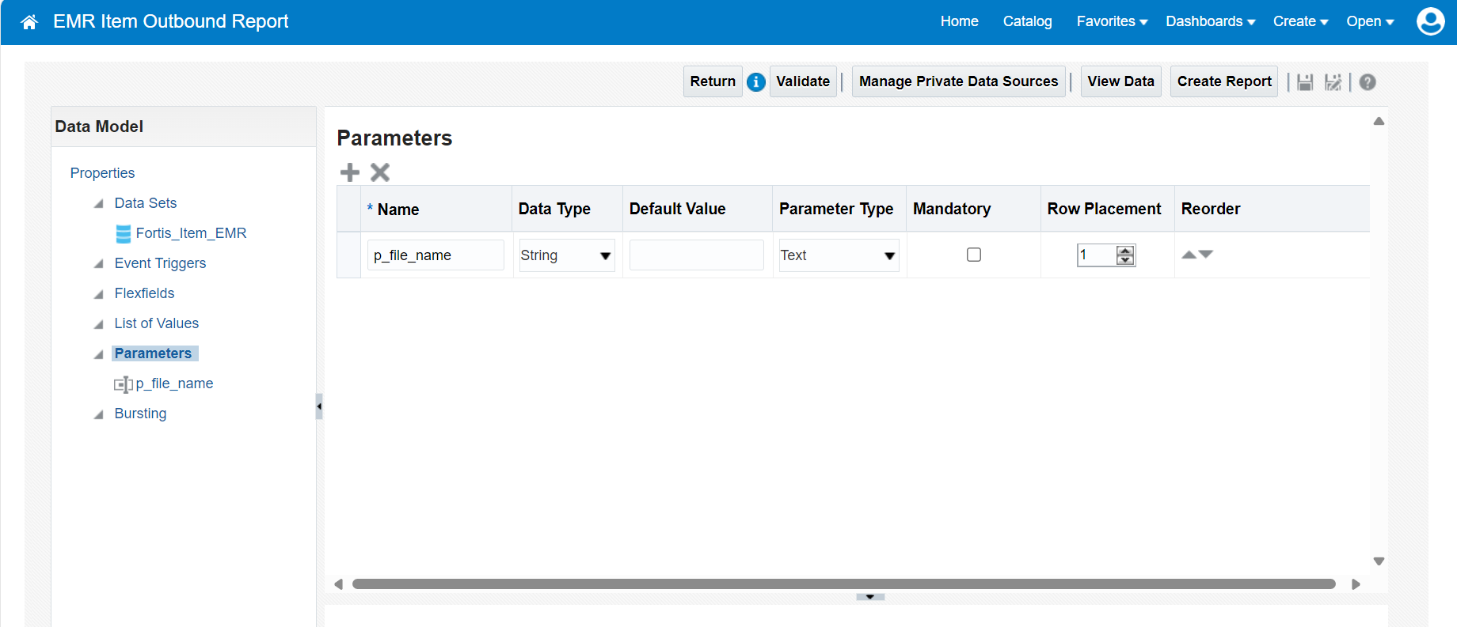

## Report

The report encapsulates the complexity of the data model and enables to define layout for the report output. Reports are secured by setting up the permission.

#### Report Details

This section enables you to enable bursting and select additional properties related to report.

|  |  |  |  |
| --- | --- | --- | --- |
| SI No | Interface Name | Report Path | Report Name |
| 1 | EMR Item Outbound Report | /Custom/Interfaces/Integration Reports/ Inventory / | EMR Item Outbound Report.xdo |

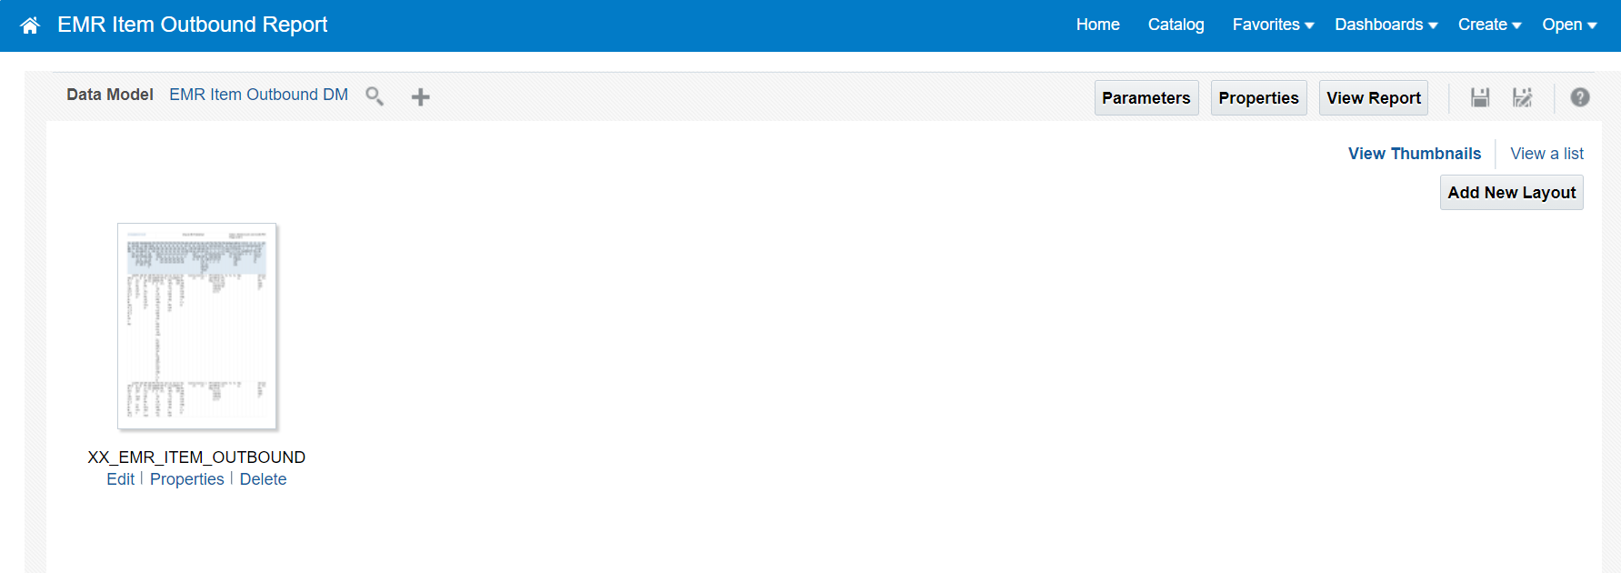

# File Processing

Bursting Logic in the report generates a xml file and places the xml file in the destination path provided in the sql logic as given below:-

**File Watcher**

The file watcher on the compute node is designed as tomcat servlet (implements ServletContextListener) reading scheduler.conf file under tomcat’s configuration directory (CATALINA_HOME/conf) to fetch the list of files to be watched for processing. The data format of the file is comma separated fields as below

**Directory:** The directory where a file will arrive

**File naming pattern:** Naming patter of the file for identification, may include wild card character as ‘*’

**invoke script:** Upon arrival of a file matching with above pattern; then shell script to invoke for processing by passing the file name as parameter

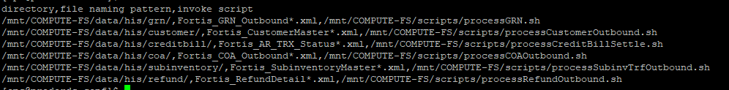

Source code of the watcher java class is a servlet which implements javax.servlet.ServletContextListener is as follow:-

The MinJob class implements Runnable is invoked by the servlet every minute to watch for a file, which primarily does the following

1. Write all the event details in CATALINA_HOME/logs/scheduler.log file using java.util.logging.logger utility
2. Reads scheduler.conf and for each line it spawns a thread to match with the naming pattern
3. If matched execute specified shell script by passing the file name as parameter.

**File Details**

|  |  |  |  |
| --- | --- | --- | --- |
| SI No | Interface | File Path | XML File Name |
| 1 | EMR Item Outbound |  | EMR_Item_Outbound_<DD-MON-YYYY_HH24_MI_SS>.xml |

**File Processing Scripts**

|  |  |
| --- | --- |
| File processing Unix script path | /u02/scripts |

Interface wise script details

|  |  |  |
| --- | --- | --- |
| SI No | Interface | SQL Loader Shell Script |
| 1 | EMR Item Outbound | EMR_OUTBOUND_SHELL_SCRIPT.sh |

**Script File processing Logic-**

1. File watcher will invoke unix script to process Item Master outbound file using shell script - EMR _OUTBOUND_SHELL_SCRIPT.sh
2. Program will zip the xml file, and then encrypt the file using public gpg key of EMR.
3. Post that create a checksum of the zip file, this checksum will be used while sending file to EMR, this is used to make sure at EMR end that file is received from actual source.
4. Now it will invoke EMR REST API to send the file to EMR

# EMR System

## EMR Services

EMR REST based web-services are used to send the outbound data from Oracle Fusion to EMR, it uses following API’s.

|  |  |
| --- | --- |
| EMR Username | EMR_Integ_USER_PROD |
| EMR Encryption Key |  |

|  |  |  |  |
| --- | --- | --- | --- |
| SI No | Service Details | Parameters | Description |
| 1 |  |  |  |
| 2 |  |  |  |
| 3 |  |  |  |

# Data FIELD Mapping

Integration data field mapping from Fusion to EMR format.

## Field to Field Mapping

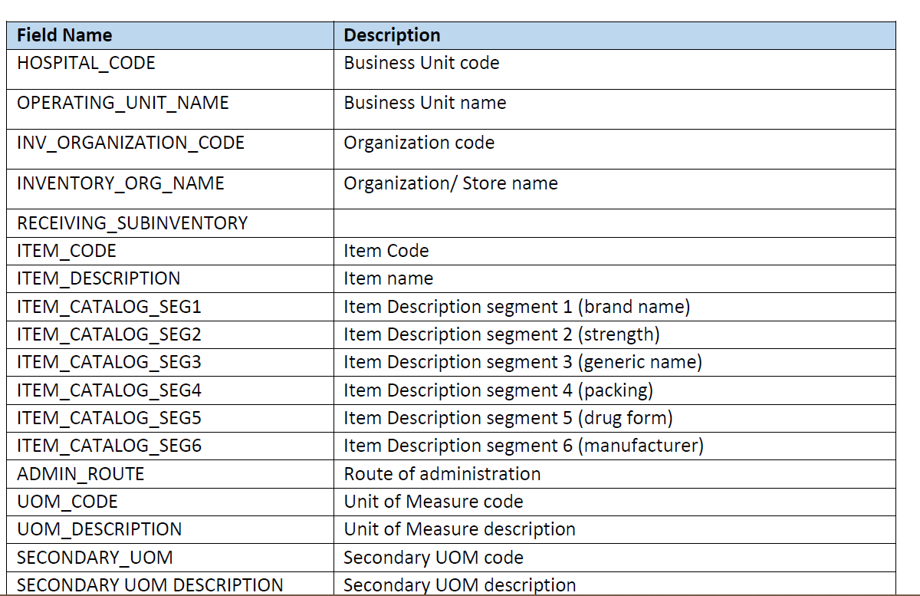

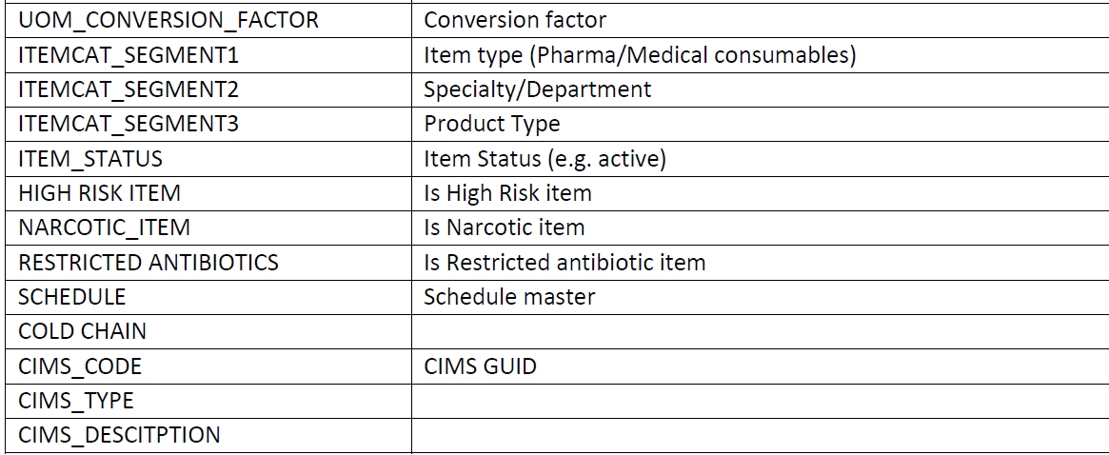

## Frequency

Repeats every 20 minutes

## File Format



## Code Pack



# Exception handling

Integration data field mapping from Fusion to EME format.

## Scenarios

The following is the list of exception scenarios –

* If item is not updated after the timestamp of previous success run, it won’t be sent to EMR.
* If there are any errors in data processing in EMR, this needs to be checked with the of EMR team.

# Assumptions / Considerations

The Proposed Solution will have the following technical considerations.

In the future, if any product bug arises in functionality then this process needs to be revisited after the bug is fixed.

# Open and Closed Issues

## Open Issues

| ID | Issue | Resolution | Responsibility | Target Date | Impact Date |
| --- | --- | --- | --- | --- | --- |
|  |  |  |  |  |  |
|  |  |  |  |  |  |
|  |  |  |  |  |  |
|  |  |  |  |  |  |

## Closed Issues

| ID | Issue | Resolution | Responsibility | Target Date | Impact Date |
| --- | --- | --- | --- | --- | --- |
|  |  |  |  |  |  |
|  |  |  |  |  |  |
|  |  |  |  |  |  |
|  |  |  |  |  |  |